Software Engineering 2017

# Group ID: A15

## *<Split Money Not Friends>*

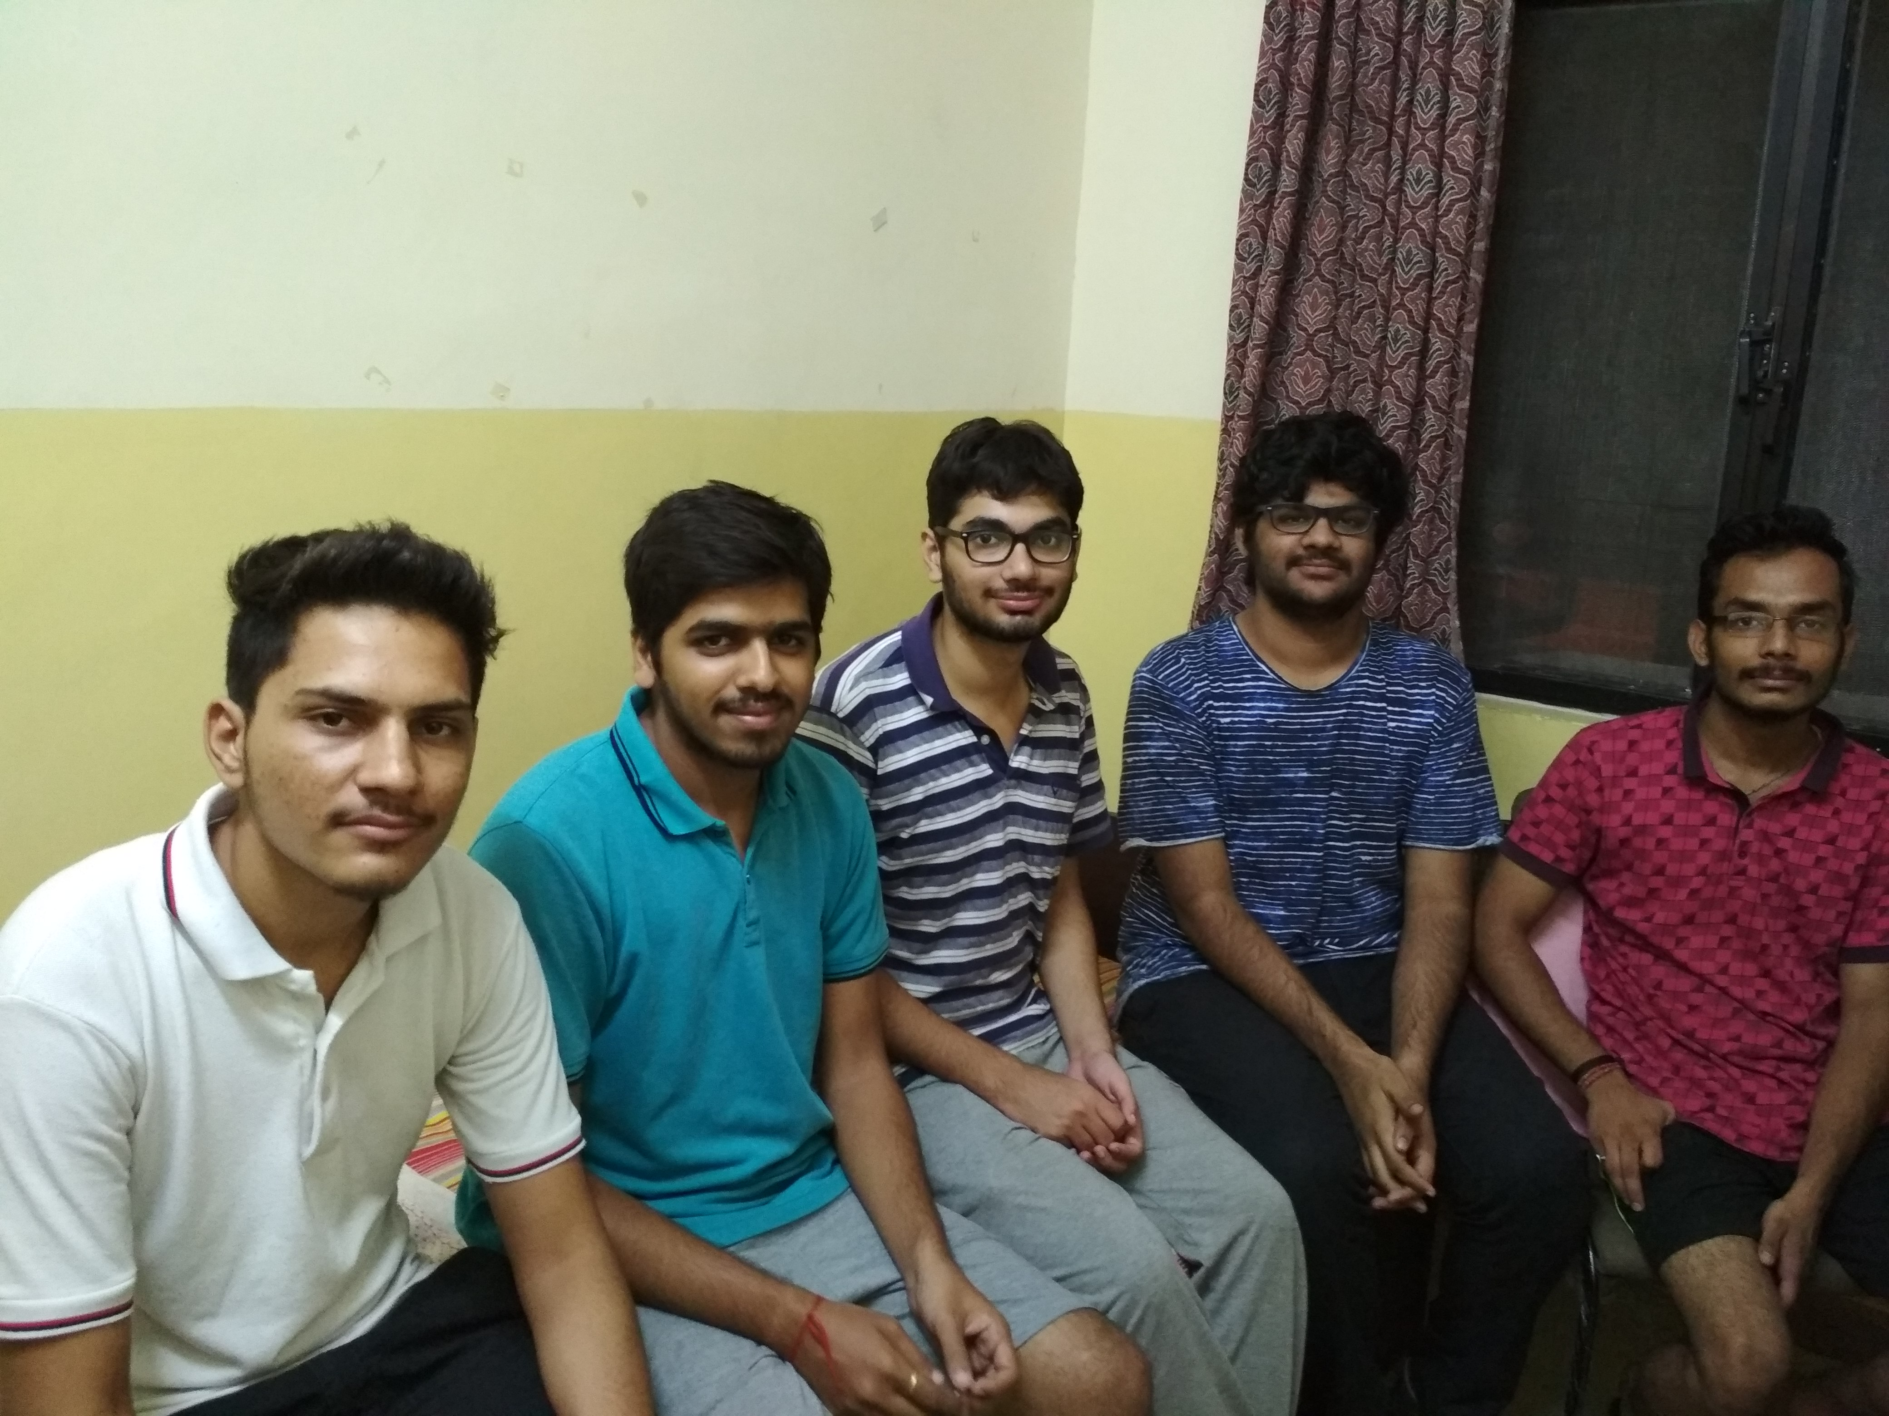

|  |  |  |
| --- | --- | --- |
| Roll Number | Name | Role (PO+DEV/SM+DEV/DEV) |
| 15ucs037 | Devendra Samatia | PO + DEV |
| 15ucs032 | Ayush Tibra | DEV |
| 15ucs099 | Pranshu Sharma | SM + DEV |
| 15ucs055 | Vinay Jain | DEV |
| 15ucs049 | Harshit Jindal | DEV |

*+ order the names as per the order in the team selfie (left to right)*

**Section 1**

|  |
| --- |
| **Project overview**   1. It aids customers and their group members to reckon the group expenses in a hassle-free, automated and the reciprocally accepted way through the means of Chat Room, E -wallet, Push Notifications and Reminders. 2. it determines the fewest number of payments needed to reconcile the debt 3. helps the management with reports and functionality to improve effectiveness of various decision-making activities. |

|  |
| --- |
| **System purpose**  It efficiently keeps the track of money expenses among group members and also calculate who owes what to whom. |

**Work System Snapshot**

**Work System Snapshot for Multiplex Ticketing System (version 2)**

|  |  |  |  |  |
| --- | --- | --- | --- | --- |
| Customers | | | Product/Services | |
| * Customer   (group member)   * Manager | | | * Push Notification * Reminder Alert * Bill Evaluator * Chat Room | |
| Major Activities and Processes | | | | |
| * Customer register and access his/her account by entering his/her details and setting up a password. * Manager sets discounts offers and special rewards for newly registered customer or frequent customers. * Customer creates group by adding new user as members or from contacts. * Customer discusses about debts and other details in a group chat room. * Customer requests system to generate final transaction statement as a record. * Customer who so creates the group may remove the group and confirms any new transaction added. * Admin verifies user details for new customers and edit group members. * Customers when removing the group, rates the user experience and gives feedback. * Customer in a group gets notification for every new transaction as a verification. * Customer will be redirected to e-Wallet to pay the bills to any group member. * Manager request system to generate daily Website traffic under filters and   compliance with site activities to make decisive measures to improve performance and make appropriate changes. | | | | |
| Participants | | Information | | Technologies |
| * Manager * Customer * Admin | * Transaction details * Feedback form * User Details | | * Email * Spreadsheet * Computer * Internet * Scanner |

**Use case diagram with nested boundary**

